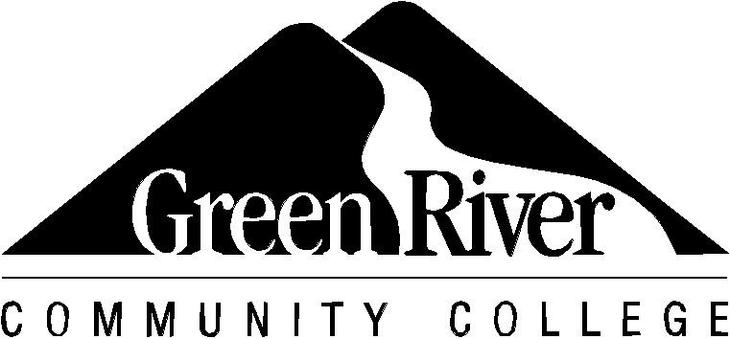

**Budget Request for Study Abroad**

|  |  |
| --- | --- |
| Student Name: | Student ID: |
| Current Email Address: | Have you been accepted into the program yet?  Yes No Not Sure |
| Program Name: South Korea Summer Program  Program website: Greenriver.edu/studyabroad | Program Sponsor: Sogang University |

Top of Form

|  |  |  |  |
| --- | --- | --- | --- |
| Program Dates:  Start:  06 / 26 / 2025 .  *month - day - year*  End:  07 / 24 / 2025 .  *month - day - year* | Circle Term(s) You Will Be Abroad:  X Summer Fall Early Fall  Winter Spring  Circle Term(s):  X Quarter Semester  Academic Year | **OFFICIAL USE ONLY**  All boxes have been completed  OIE Staff Initials:  date stamp here | |
| **Item** | | | **Cost** |
| Program Fee: Includes housing, weekly cultural activities, and orientations. | | | **$2,400 -$2,600\*** |
| WCCCSA Administrative Fee | | | **$105** |
| Tuition + Fees (you may choose to take 5 or 10 credits) | | | $637.95- $1,300 |
| Airfare (estimate only) | | | $1,300 |
| Emergency Medical Insurance (Required) | | | $75 |
| Food (meals are not provided) | | | $400 |
| Personal Incidentals (ex: sim card/data plan) | | | $65 |
| **Estimated Total\*\*** | | | **$4,983-$6,000** |

*The program fee is paid in Korean currency and the exact price paid will vary depending on the exchange rate

at time of payment.

**This is an estimate only and does not include independent activities, travel, or entertainment costs.

Study Abroad Campus Coordinator___*__________*________________ Date__________