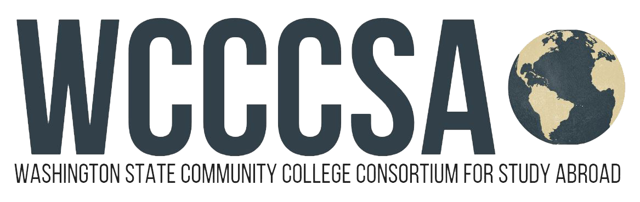

**Washington Community College Consortium for Study Abroad (wcccsa.com)  
FACULTY APPLICATION INFORMATION**

WCCCSA seeks enthusiastic and creative faculty who can demonstrate a history of effectiveness in their instructional discipline and the ability to successfully forward student participation and academic progress. Interested instructors need strong interpersonal communication skills and a keen awareness of the realities of providing instruction to U.S. community college students overseas. A strong foundation in intercultural awareness/communication, student development, and cross-cultural adjustment is required to teach on a WCCCSA program.

Faculty applicants are evaluated on the following criteria:

1. Relevance of the proposed course to its respective environment
2. Applicability of proposed courses to general education distribution requirements and courses’ appeal to the general students (without prerequisite preferred, generally no access to lab or studio space on site)
3. Ability to build inclusive group dynamics in a space where students of different backgrounds and identities (including students who experience barriers to education) can thrive while learning, living, and traveling together
4. Positive record of college-level teaching excellence with proposed or similar courses
5. Previous international education experience and student service experience
6. Positive record of collegial cooperation and interdisciplinary instruction

To apply to teach on a WCCCSA program, please complete the application form and submit all supporting documents.

**APPLICATION DEADLINES*:**

* **Friday, March 28, 2025**

For Berlin, Germany Spring 2026 program AND Dublin, Ireland Fall 2026 program

Interviews are expected to be held in May.

***\*Note****: Complete applications must be received in the office by this date. Only complete applications will be considered. Once submitted, applications cannot be changed or amended for reconsideration.*

*You may apply for more than one program, but you must submit a separate application package for each program.*

Send your application packet **electronically** to:

Li Liu, WCCCSA Co-chair

Bellevue College

li.liu@bellevuecollege.edu

**Thank you for your interest in teaching for the Washington State   
Community College Consortium for Study Abroad (WCCCSA)!**

*WCCCSA Faculty Application*

# Contact Information

Name:

E-Mail Address:

Telephone #:

School: Academic Discipline:

I am (check one) ☐ Associate Faculty ☐ Full-time Faculty ☐ Full-time/Tenured Faculty

# Program to which you are applying: (select one)

|  |  |
| --- | --- |
| ___Berlin, Germany  Spring Quarter 2026 | ___Dublin, Ireland  Fall Quarter 2026 |

# Supporting Documentation

Please attach the following documents to this application:

☐ Knowledge, Skills, and Abilities Questionnaire

☐ A proposal of three, 5-credit classes within your discipline that **you have taught before the start of the program you are applying for.** For each class, please include the title and course number (at your campus), the department, a brief course description, and an explanation of how you will integrate the location and its cultural venues into the courses. If selected to teach on the program, WCCCSA will ask you to teach two of the three courses (a third course will be taught by our international partners).

I have taught the proposed classes before. (Initial).

☐ Curriculum vitae.

☐ A letter from your Division Chair/Dean confirming your qualifications and stating your college’s support of your participation in a WCCCSA program. The letter should also state that your campus agrees to pay your salary while overseas with WCCCSA.

**Please read the following and sign:**

“I understand that if I am selected for the WCCCSA program my salary will be paid by the college supporting my participation in this program. I further understand that my college will determine the amount of this payment. I understand that WCCCSA will pay my college a portion of the faculty replacement costs for the term that I am abroad and consequently make no salary payment to me. I also understand that low enrollment in the program could affect how many or if any faculty go and could lead to the cancellation of the program.”

Faculty Signature: Date:

WCCCSA Coordinator Signature *(Required)*: Date:

(When your application is complete, ask the study abroad coordinator on your campus to sign this form)

*WCCCSA Faculty Application*

*Knowledge, Skills and Abilities Questions (800 word total limit)*

1. What do you hope to gain personally and professionally from teaching abroad with WCCCSA?
2. Following your teaching abroad experience, what will you bring back and how will you promote internationalization on your home campus?
3. If selected to teach for our program, you will be teaching two classes as opposed to a full load of three classes. How would you utilize the release time to support your students in their study abroad experience?
4. We are finding that more students with disabilities (including physical, mental, behavioral and learning/neurological) are participating in WCCCSA programs. While the Americans with Disabilities Act is only applicable in the USA, WCCCSA does strive to accommodate student needs as much as possible depending on the host site restrictions. Describe an instance in which you accommodated a student with disabilities in your classroom.
5. Please give an example of your work with students who experience barriers in education (such as BIPOC, First-Gen, LGBTQIA+, students with disabilities, etc.) and your methods to support their success in academic spaces.