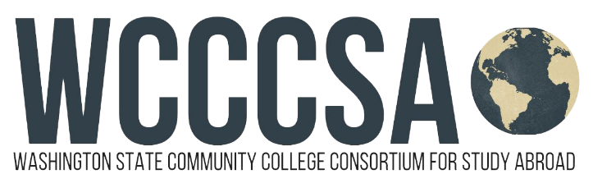
Budget Request for Study Abroad

Student Name: | Student ID:
Current Email Address: | Have you been accepted into the program yet?  Yes No Not Sure
Program Name: WCCCSA  Program website: www.wcccsa.com | WCCCSA Program: 2024 Fall Quarter Lyon, France Program in partnership with CEFAM

Program Dates:  Start:  09 / 30 / 2024 .  month - day - year  End:  12 / 07 / 2024 .  month - day - year | Term(s) You Will Be Abroad:  Fall  Program Length:  Quarter

Information below includes estimates; update if needed for your own circumstances:
Program Fee: | $6,250
Tuition: 15-credits, rate varies by college Approx. | $1,600
Textbooks & supplies Approx. | $50
Food (Daily Lunch and Dinner on weekends) Approx. based on $32 per day | $2,000
Roundtrip Airfare: Flight from SEA to Lyon, France Approx. | $1,000
Local Transportation Approx. | $200
Program-related Personal Expenses (laundry, telephone, personal travel): Approx. | $500
Estimated Total | $11,600
WCCCSA – Study Abroad Coordinator Signature | Date

